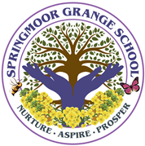

The following information is required by the Department of Education to complete the School Census. This is a legal requirement for us to complete. Please provide your child’s country of birth and nationality as recorded on their birth certificate, or on a passport or EU ID card.

In addition, we are offering you the opportunity to record the languages your child uses.

Pupil name:  ………………………………………………………………………………. | Reception/Nursery Class …………..….

Pupil’s Country of Birth | Name of country | I do not wish this to be recorded | Not known

Pupil’s Nationality  or Dual Nationalities | Nationality /Nationalities | I do not wish this to be recorded | Not known

Language(s) used within family from birth

c
Where your child was exposed to more than one language (which may include English) from birth up to starting school, please tell us what that language was, no matter how good your child's English is now.

